HVAC (Heating, Ventilation, and Air Conditioning) (4.0)
- HVAC Monitoring System Using STM32MP135F‑DK and PyModbus
1. Introduction
HVAC stands for Heating, Ventilation, and Air Conditioning. It is a system used to control temperature, humidity, and air quality in buildings such as industries, hospitals, malls, and offices.
In this project, the HVAC parameters are monitored using an STM32MP135F‑DK board running Linux. The system communicates with the HVAC controller/HMI using the Modbus RTU protocol. Python with the PyModbus library is used to read real‑time data such as temperature, pressure, and actuator values.
2. Objective of the Project
- To monitor HVAC system parameters
- To read sensor data from the HVAC controller
- To communicate using the Modbus RTU protocol
- To display real‑time data using Python in Linux
3. Components Used
- HVAC System / Training Setup
- STM32MP135F‑DK Board
- Linux Operating System
- Python Programming
- PyModbus Library
- USB to RS‑485 Converter
- HMI / HVAC Controller
- Temperature Sensors
- Pressure Sensors

4. System Architecture

System data flow:

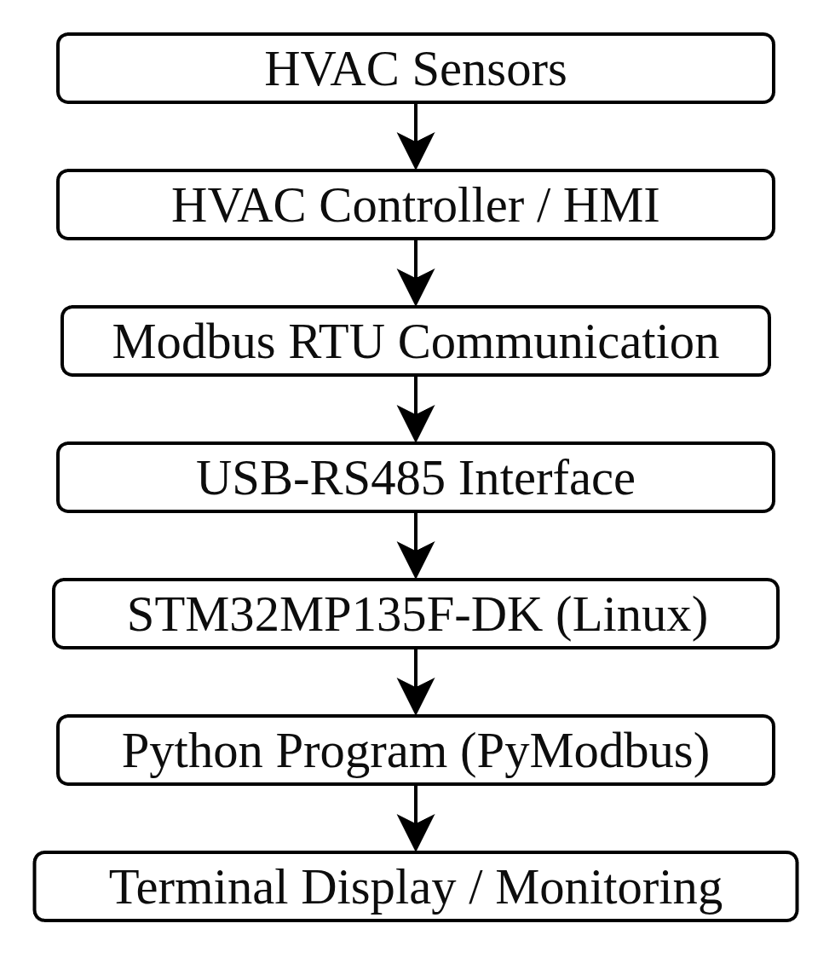

5. Working Principle

The HVAC system consists of several components such as compressor, condenser, evaporator, cooling tower, and fan coil unit.
Temperature and pressure sensors continuously measure system conditions. These values are stored in Modbus registers in the HVAC controller.
The STM32MP135F‑DK board reads these values using Python and PyModbus through Modbus communication and displays them for monitoring.

6. Methodology (Step‑by‑Step Process)

Step 1 – Hardware Setup

The HVAC system sensors are connected to the HVAC controller or HMI.
Step 2 – Communication Setup
A USB to RS‑485 converter is connected between the STM32MP135F‑DK board and the HVAC controller.

Step 3 – Linux Environment
The STM32MP135F‑DK board runs a Linux operating system, which allows Python programs to run.

Step 4 – Install PyModbus
And also venv in linux stm32
Refer :https://drive.google.com/file/d/1w6EOh4rDZ1l9sPQZsmLk4W_zcdGgwfI1/view?usp=sharing

The PyModbus library is installed in Python to allow Modbus communication.

### pip install pymodbus ###

Step 5 – Establish Modbus Connection
The Python program connects to the Modbus device using serial communication.
Example parameters:
- Port: /dev/ttyUSB0
- Baudrate: 115200
- Slave ID: 3

Step 6 – Read Modbus Registers
The Python script reads holding registers that contain HVAC data.
Each sensor value is stored in two 16‑bit registers, forming a 32‑bit floating value.

Step 7 – Convert Data
The program converts register data into floating‑point values using the Python struct library.

Step 8 – Display Parameters
The program prints important HVAC parameters such as:
- FCU Temperature
- Condenser Temperature
- Evaporator Temperature
- Room Temperature
- Low Pressure
- High Pressure
- Water Pressure
- Actuator Position

Step 9 – Monitoring
The system continuously monitors the HVAC system and displays real‑time data.

7. Example Output Parameters
The program displays the following parameters:
- FCU In Temperature
- Condenser Out Temperature
- Evaporator Out Temperature
- FCU Out Temperature
- Evaporator In Temperature
- Geyser Temperature
- Low Pressure
- High Pressure
- Water Pressure
- Room Temperature
- Heater Actuator Percentage
- Chill Water Actuator Percentage

Output Method
open Modscan github download link
- Release Open ModScan 1.13.1 · sanny32/OpenModScan · GitHub

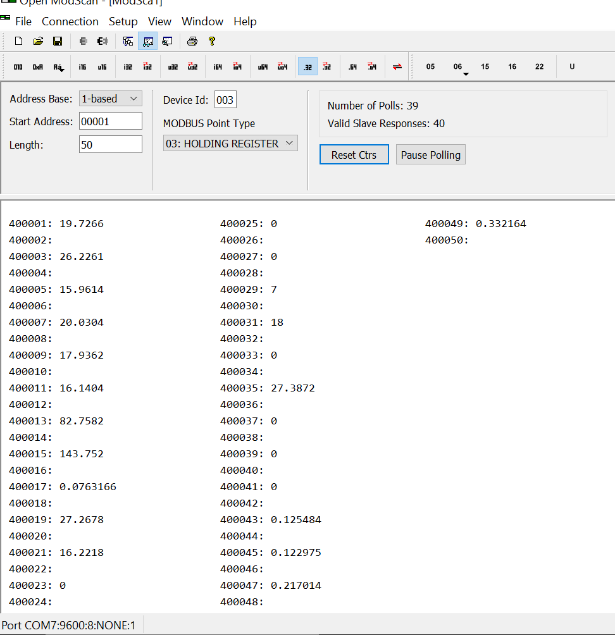
Fig 1 :Using OpenModbus(open source)
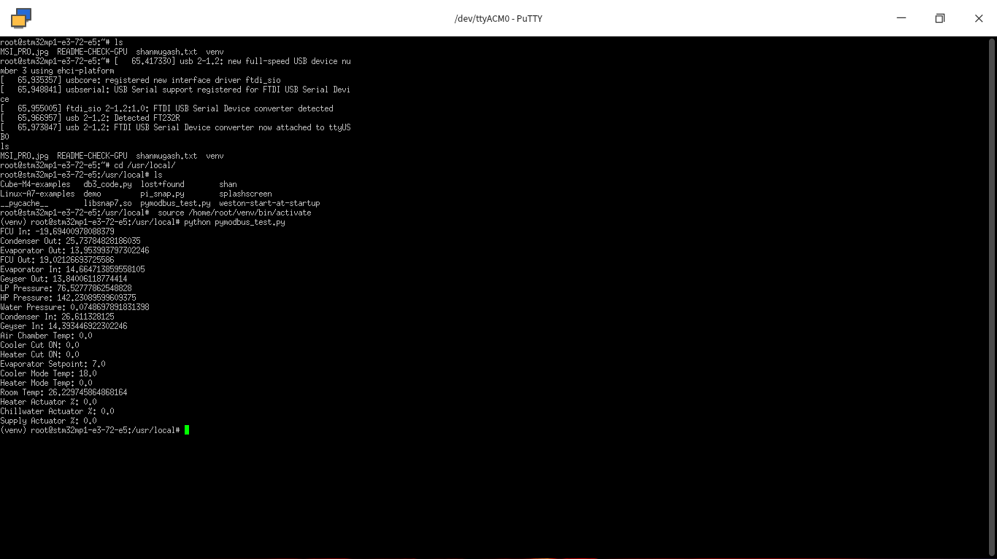

Fig 2: STM32MP135F‑DK (Linux with PyModbus)(putty serial out)
refer (linux_step.txt)
- linux_step.txt
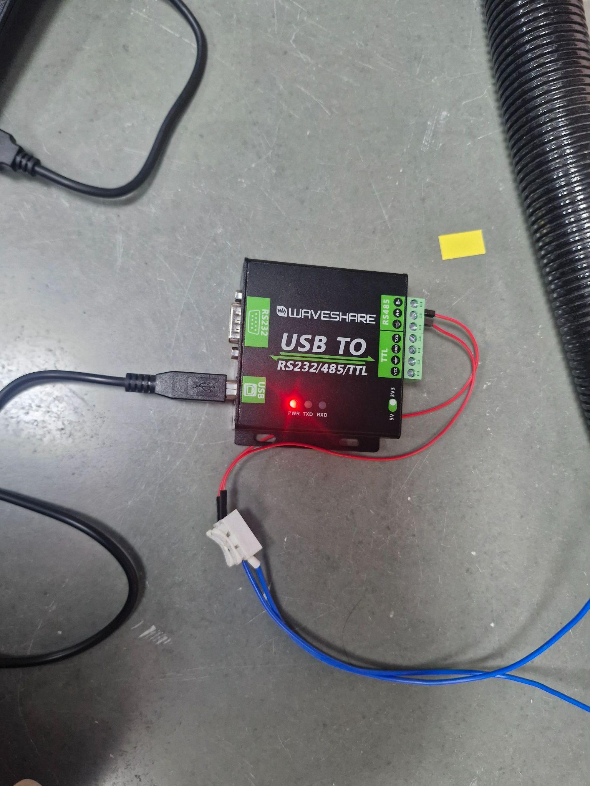
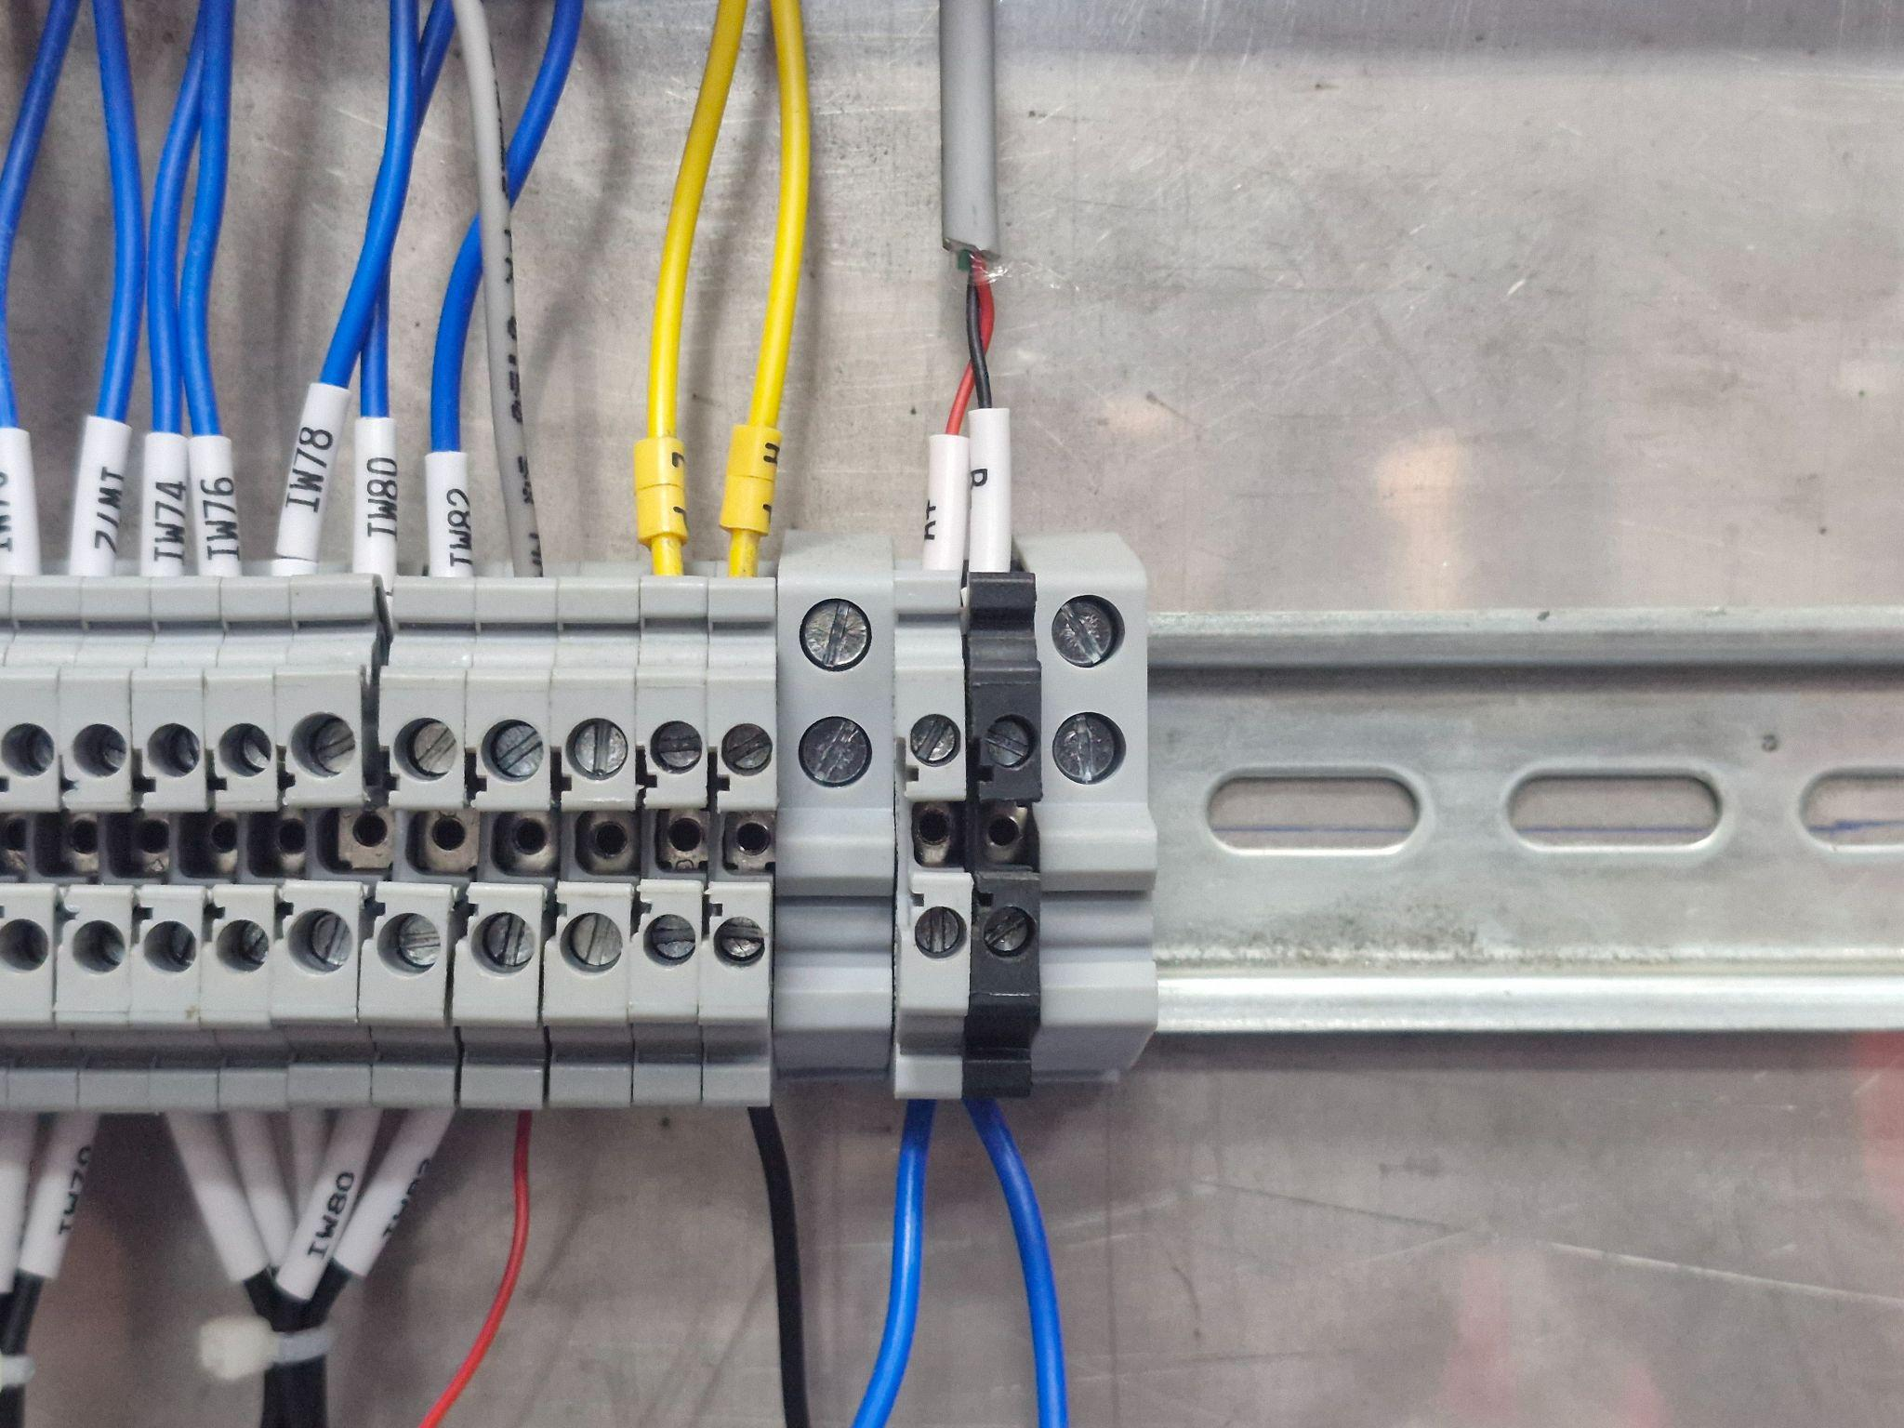
- https://drive.google.com/file/d/137Z4e6KkE76g4yM_h6BWm3Y-f9gjC6Qb/view?usp=sharing

Fig 3: Modbus in HVAC fig 4: RS485 to USB

